White Paper PoC
Prismatic Tesseract Energy Core (PTEC)
with Ring-Gated Plasma Vectoring and SCDE Torque Control
  - Concept paper for a speculative field-routed propulsion and power architecture
Prepared for: Quellaran / GhostCore concept archive
Version: v1.0
Date: 2026-03-15
Scope note. This document is a speculative proof-of-concept. It combines plausible subsystems—such as plasma routing, electromagnetic vector control, and photon-momentum micro-thrust—with conceptual architectures that are not established propulsion science. Internal field switching alone does not create net translation; measurable craft movement still requires momentum exchange with an external medium or directed radiation.

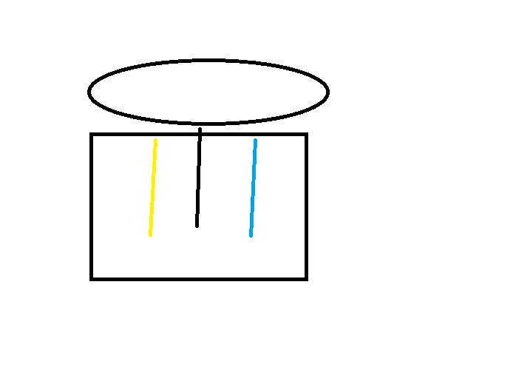
Figure 1. User concept sketch showing two vertical vector channels within a ring-gated arrangement.

Executive Summary
This paper reframes the user’s concept as a layered architecture: a PTEC core provides electrical and field energy; a ring of ion/plasma switches acts as a vectoring manifold; and SCDE counter-polarized wraps add torque, phase bias, and orientation control. The result is a single assembly that can operate in three modes: closed-state power conditioning, open-state directional plasma/energy routing, and torque-state spin or attitude modulation.
The paper’s central claim is modest: the geometry may be useful as a control and routing architecture even where the stronger propulsion claims remain speculative. In other words, the concept is strongest when treated as a field-control stack first and a breakthrough drive second.

1. System Architecture

1.1 Layered assembly
Layer A — PTEC core: A polyhedral plasma-induction reactor concept intended to supply continuous power, field resonance, and directional energy bias.
Layer B — Ring-gated ion/plasma switch manifold: A circular array of fast plasma or ion switches positioned above or around the PTEC output aperture. Sequential firing or polarity reversal selects the active vector path.
Layer C — SCDE wrap logic: Counter-polarized electric and plasma wraps placed along the active channel to create controllable curl, torque, and phase asymmetry without mechanical gimbals.
Layer D — External coupling or exhaust path: A required path for real net thrust if the vehicle is intended to translate. Candidate mechanisms include expelled plasma, directed photon emission, or external magnetic coupling.

1.2 Functional flow
Subsystem | Primary role | Control variable | Expected output
PTEC | Power generation and resonance | Rail rotation, plasma phase, gate state | Conditioned field energy
Switch ring | Directional routing | Switch sequence, polarity, aperture timing | Up/down or lateral vector bias
SCDE wraps | Torque and attitude modulation | Phase offset, wrap polarity, pulse frequency | Spin, curl, orientation control
External coupler | Momentum exchange | Mass flow or radiated power | Measurable thrust

2. Operating Modes
Mode 1 — Closed-state power routing: The prism gates remain sealed and the switch ring is used for internal load balancing, field shaping, and power delivery to onboard systems.
Mode 2 — Dual-direction vector routing: Top and bottom gates alternately open while the ring reverses sequence or polarity, allowing the active channel to bias upward or downward.
Mode 3 — SCDE torque steering: The switch ring establishes a primary channel, then SCDE wraps inject controlled phase divergence to create spin-state bias, hover stabilization, or attitude correction.
Mode 4 — Physical thrust mode: Only valid when paired with a real momentum-exchange mechanism such as propellant exhaust or directed electromagnetic emission.

3. Physics Boundaries and What Is Testable
A ring of ion or plasma switches can plausibly act as a high-speed manifold for containment, routing, pulsed discharge control, and vector selection. That part belongs to known engineering categories such as plasma valves, electromagnetic steering, and phased field control.
Internal switching alone does not yield net propulsion. A sealed system can re-route energy and redistribute forces internally, but center-of-mass translation still requires exchange of momentum beyond the closed system boundary.
The cleanest measurable PoC path is therefore to separate control claims from thrust claims. The control claim can be tested with plasma channel steering and torque-state bias. The thrust claim can be tested only by coupling the assembly to an external reaction mechanism.

4. Proof-of-Concept Roadmap
Phase | Objective | Bench setup | Measurement | Exit criterion
I | Demonstrate switch-ring steering | Cold plasma or ionized gas channel with segmented ring electrodes | Optical plume shape, current path, repeatability | Stable up/down path selection
II | Demonstrate SCDE torque bias | Coaxial plasma path with counter-polarized wrap sections | Angular response, phase-lock behavior | Repeatable orientation change without moving gimbal
III | Demonstrate real thrust | Attach external exhaust path or directed-radiation module | Thrust stand, power meter, null tests | Force scales with exhaust momentum or P/c
IV | Integrate control stack | Combine PTEC-like source, switch ring, and SCDE logic | Thermal, EMC, stability, duty cycle | Sustained operation without runaway instability

5. Proposed Measurements
Electrical: bus voltage, current draw, switching frequency, phase offset, ring timing jitter.
Plasma: optical emission, line-integrated density, temperature proxy, plume divergence, confinement stability.
Mechanical: torsion or pendulum displacement, angular rate, vibration isolation, cable-force compensation.
Thermal and EMC: wall temperature, support expansion, stray Lorentz coupling, RF leakage, induced currents in nearby structure.

6. Key Risks and False Positives
• Thermal deformation causing apparent force or rotation.
• Electromagnetic coupling into test stand supports, cables, or nearby metal.
• Gas leaks or boil-off jets masquerading as thrust.
• Control software instability causing switching artifacts misread as novel physics.
• Over-interpretation of torque-state reorientation as reactionless translation.

7. Conclusion
The most defensible version of the concept is a field-routed control architecture built around a central PTEC-like energy source, a ring-gated plasma switch manifold, and SCDE torque wraps. In that form, the design has a coherent speculative path toward vector routing, pulse control, and attitude modulation. Claims of full propulsion should remain explicitly conditional on a verified external momentum-exchange mechanism.
That keeps the paper honest, testable, and still ambitious—an engineering stance with fewer miracles and better instrumentation.

Appendix A. Source Concept Threads Incorporated
PTEC: rotating polyhedral plasma-induction core, prism gates, standing-wave and directional-bias logic.
SCDE: counter-polarized plasma-electric wraps for spin-state induction and propulsive torque generation.
Photon / micro-Newton baseline: any true reactionless claim should be benchmarked against known momentum-transfer methods such as directed radiation.

